Created by: David Rubio G.
Blog: https://soceame.wordpress.com/
GitHub: https://github.com/DRubioG
Last modification date: 11/03/25

Before you start
If you also work with a PolarFire SoC Discovery Kit I recommend you download this GitHub repository. It has the base configuration to enable the MSS processor and also has an example project that we will work with, which also includes all the drivers you may need for a PolarFire.
If you do not work with this kit I also recommend you download it because the SoftConsole base project is common to all boards.
https://github.com/DRubioG/Polarfire_basic_project
We will only need the mpfs-blinky and the PolarFire_config. The other file is like the PolarFire_config but applied to the complete Discovery Kit.
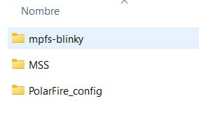

Libero
The first step is to create a new project in Libero.
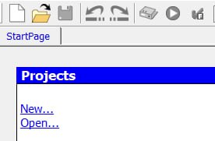
We give the project a name and a location.
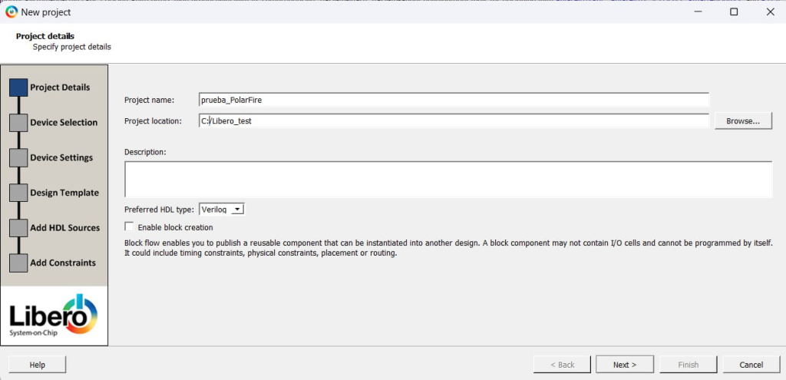
Then we choose the chip and click Finish.
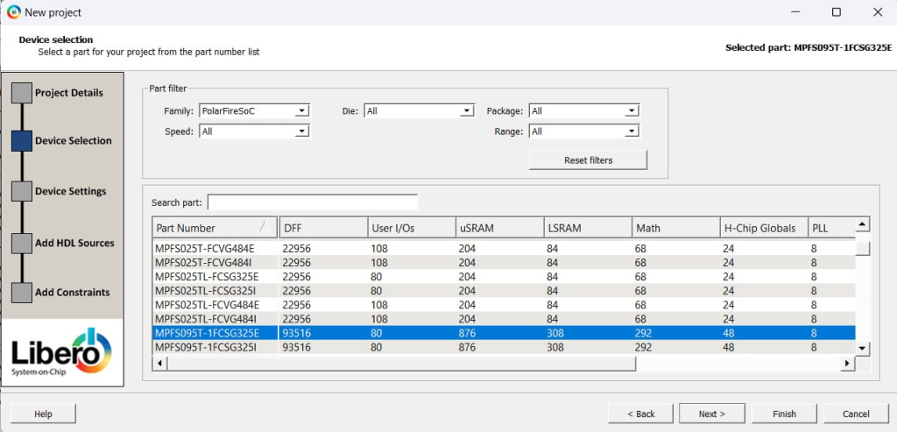
We click Import MSS and import a .cxz that is from the repository.
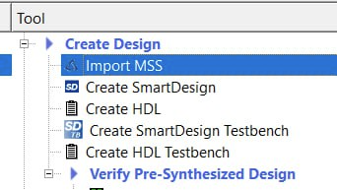
The one you need to import.
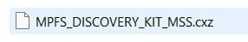
To create your own you have this tutorial.
https://soceame.wordpress.com/2025/03/11/configuring-the-peripherals-of-a-polarfire-soc/
In the hierarchy we have the following.
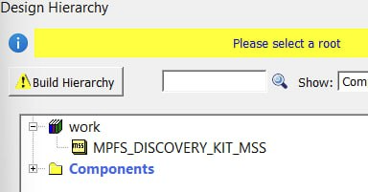
Now we create a SmartDesign.
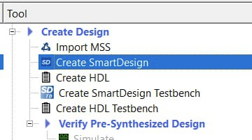
We call it Polarfire_test.
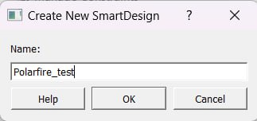
We get a structure like this.
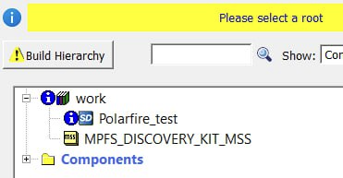
We select the SmartDesign as Root.
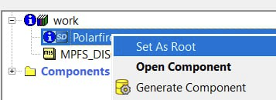
Now we drag the PolarFire SoC model to the SmartDesign.
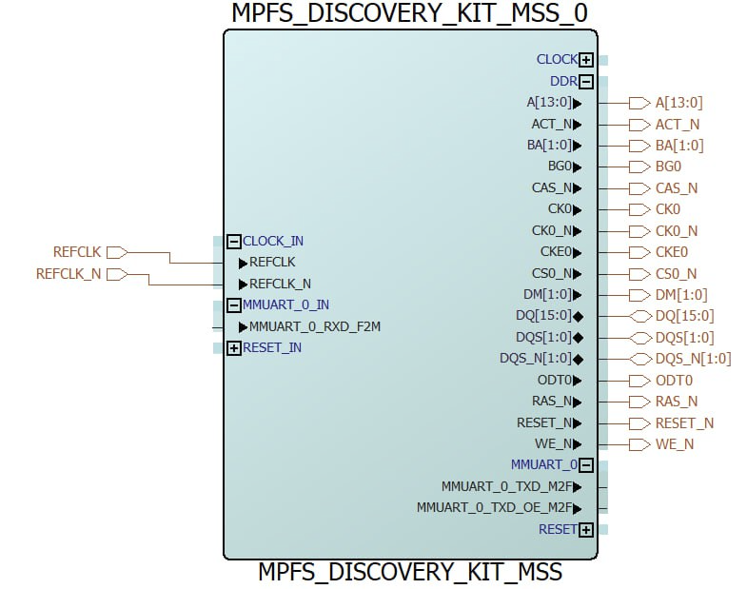
Now we connect only the UART ports that are as Fabric.
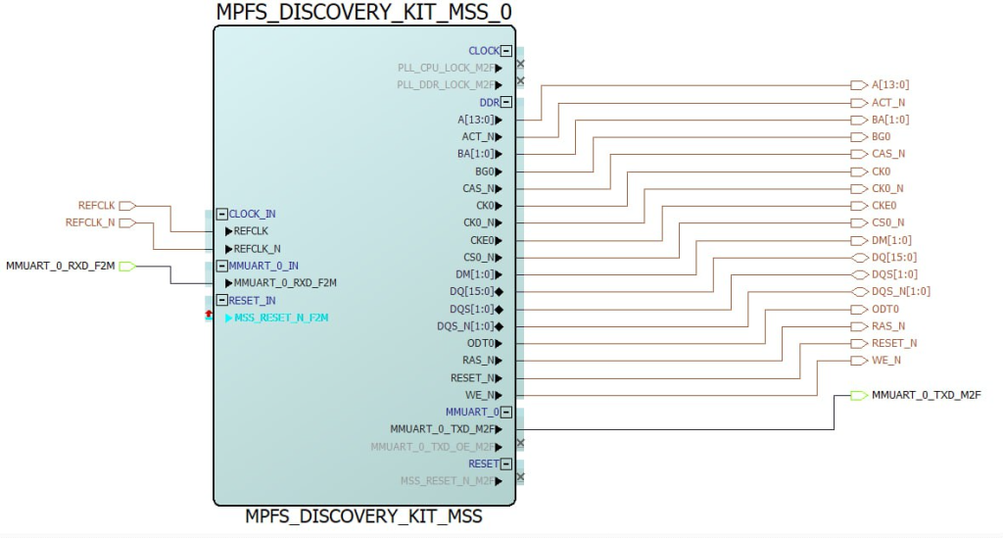
Now we have a structure like the following.
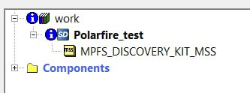
If you want to connect other IP blocks you can do it by following this.
https://soceame.wordpress.com/2025/03/11/how-to-connect-an-ip-block-in-libero/
When we have everything, we synthesize.
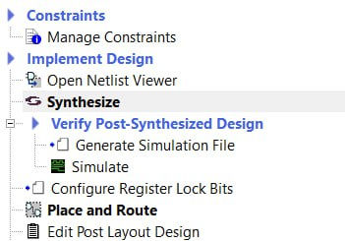
Now in Manage Constraints we can configure the UART pins as Fabric.
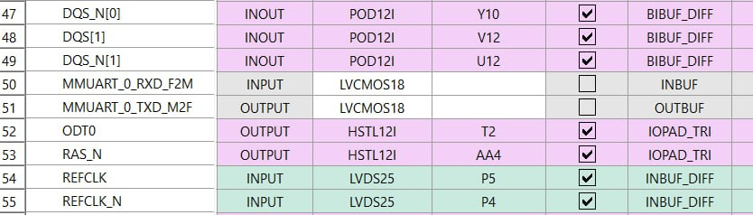
Now we select them.
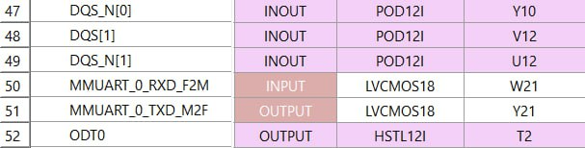
Once selected we can generate the bitstream.
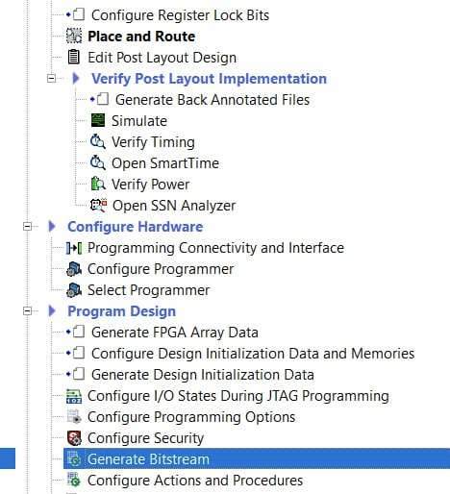
Once we have it we can record it to the SoC.
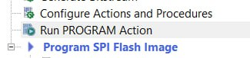
Now we go to the SoftConsole.

SoftConsole
Now we import a project, to do this we click on Import…
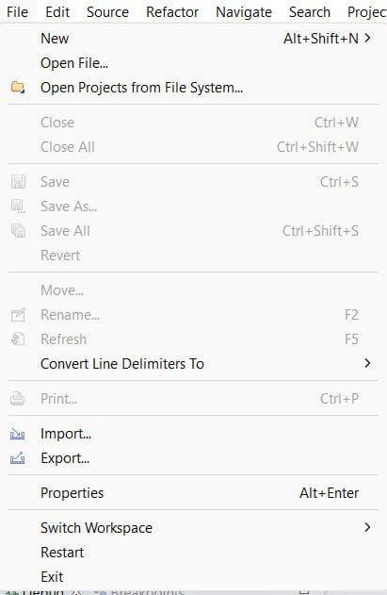
Then we click on Importing an Existing Projects into Workspace.
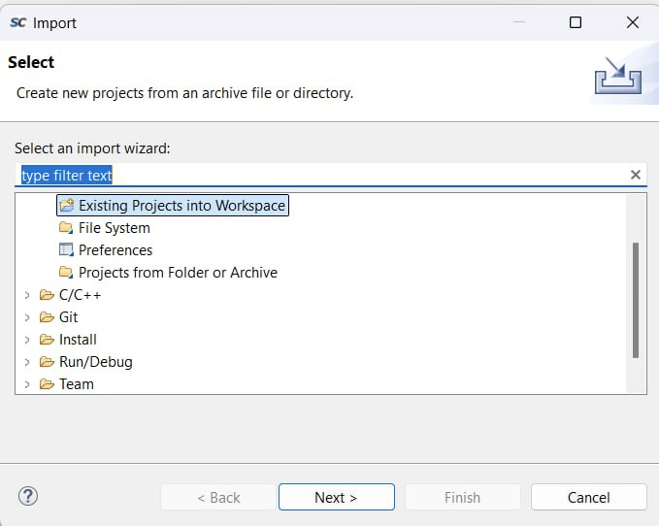
Now we look for the mpfs-blinky, and we import it (you may have to go down one more directory so that the SoftConsole project is supported).
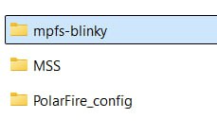
Once we have imported it, we compile it.
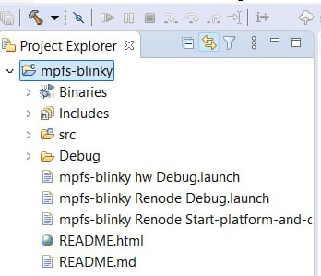
Once we have compiled it we can debug it.
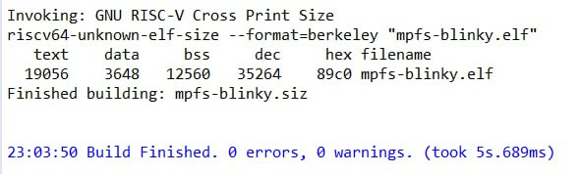
To do this we go to Debug Configurations…
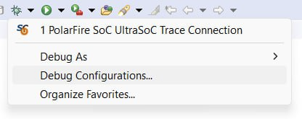
Now we look for the mpfs-blinky hw Debug, and we launch it.
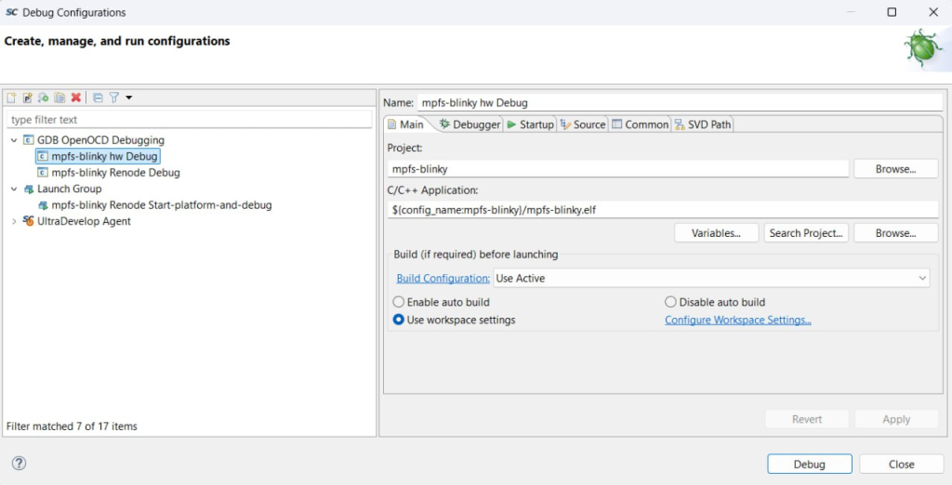
If we open the terminal we can see that the application runs correctly.
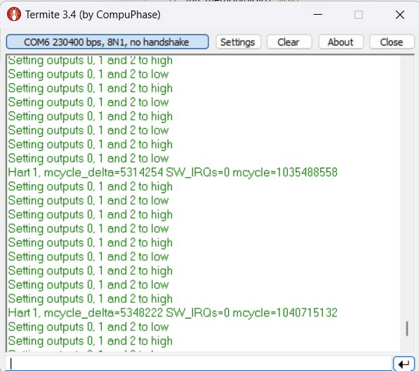
If we analyze the code, we can see that there is a UART and some GPIOs in the example. The GPIOs do not work (I have not managed to get a PolarFire to be able to run, because it does leave something with the GPIOs assigned from the PolarFire).
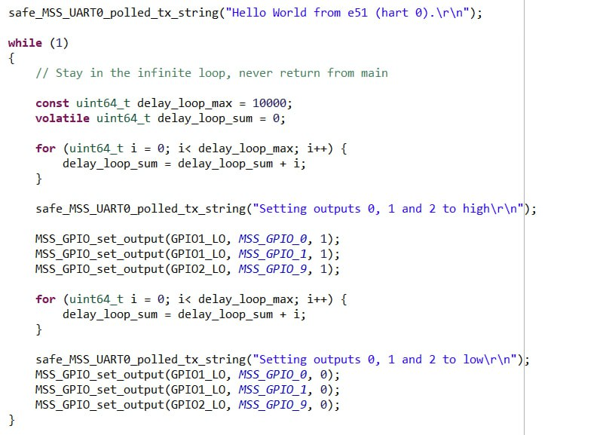
The UART operation looks easy, but an intermediate UART appears. That comes from here.
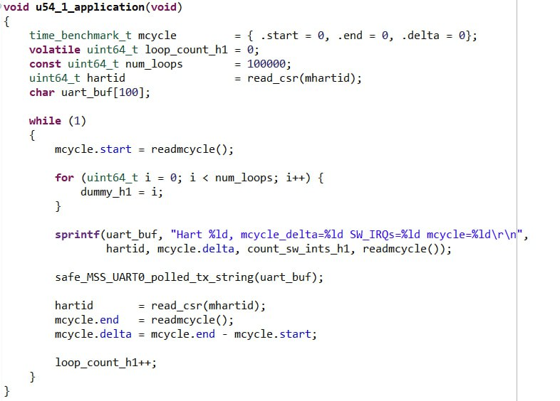
The last thing we have seen is the execution on a second core, so the application can only be executed with two cores, e51 and e54_1, (if you try to remove one of the two cores, which seems easy but is not even close, you run the risk of everything stopping working, and the board going «dumb», and you having to quit everything and return).
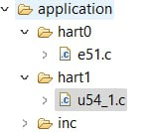
NOTE: if you look at the UART baud rate, you can see that it has been set to 115200 baud, but the Termite is set to 230400, this is because this SoC, like the SmartFusion2, has a design problem, which theoretically is solved at the driver level, but which Microchip has not wanted to solve. This problem is that the core frequency has to be a specific one that Microchip never says, so if the frequency that the core needs is 50MHz, but you feed it at 100MHz, the board doubles its frequency at the peripheral level making a 115200 UART go to 230400 (this happens at all UART baud rates). This is supposed to be solved at the driver level, but it isn’t, so it’s important to keep this in mind.

FINAL NOTE
Working with a PolarFire SoC may look like a SmartFusion2, but it’s not. PolarFire SoCs at the time of writing this are extremely difficult to handle. So if you know how to handle a SmartFusion2, stick with it.

